* Assignment 3: Feature Branches and Hotfixes

Create a 'hotfix' branch to fix an issue in the main code. Merge the 'hotfix' branch into 'main' ensuring that the issue is resolved.

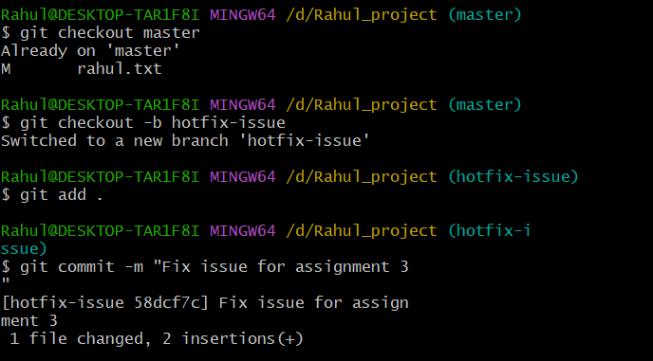

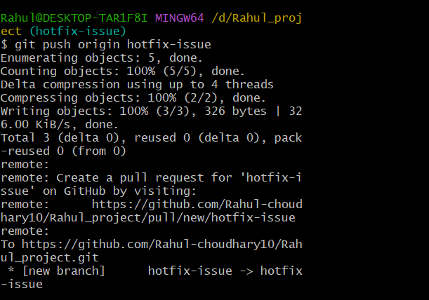

* Create a Pull Request (PR) on GitHub

1. Go to your repository on GitHub.
2. Click on the 'Pull requests' tab.
3. Click 'New pull request'.
4. Set the base branch to 'main' and the compare branch to 'hotfix-issue'.
5. Click 'Create pull request' and provide a brief description of the changes made.

* Merge the Pull Request on GitHub

1. After the PR is reviewed and approved, click 'Merge pull request'.
2. Confirm the merge by clicking 'Confirm merge'.
3. (Optional) Delete the 'hotfix-issue' branch on GitHub if it is no longer needed.

